Fitness Tracking Enhancement — MediaPipe Pose & OpenCV

IMPLEMENTATION

MediaPipe: It is a real-time framework for human pose estimation, detecting 33 key body landmarks using AI-based models. It is lightweight, efficient, and optimized for low-latency processing, making it ideal for fitness tracking, physiotherapy, and gaming. The library runs smoothly on standard devices without requiring additional sensors.
OpenCV: It is an open-source library for image processing and video analysis, enabling real-time video capture and frame manipulation. It helps preprocess images, convert color formats, and display pose detection results seamlessly. Its integration with MediaPipe ensures smooth real-time visualization of detected landmarks.
Numpy: It is a numerical computing library used for storing and manipulating pose landmark coordinates efficiently. It performs vector operations, joint angle calculations, and interpolation of missing data for movement analysis. Its optimized array processing enhances real-time pose estimation performance.
Modules Description:

1. Video Capture Module – Captures real-time video input from a camera for pose detection.
2. Preprocessing Module – Converts the video frames to RGB format and prepares the data for analysis.
3. Pose Detection Module – Uses MediaPipe Pose to detect human body landmarks and track movements.
4. Feature Extraction Module – Identifies key joints and extracts relevant positional data for analysis.
5.Angle Calculation Module – Computes joint angles to analyze body posture and movements.
6. Feedback & Visualization Module – Displays detected poses, calculated angles, and real-time feedback on-screen.
7.Application-Specific Module – Implements logic for use cases like fitness tracking, physiotherapy, gesture recognition, or sports analytics.

SYSTEM ARCHITECHTURE

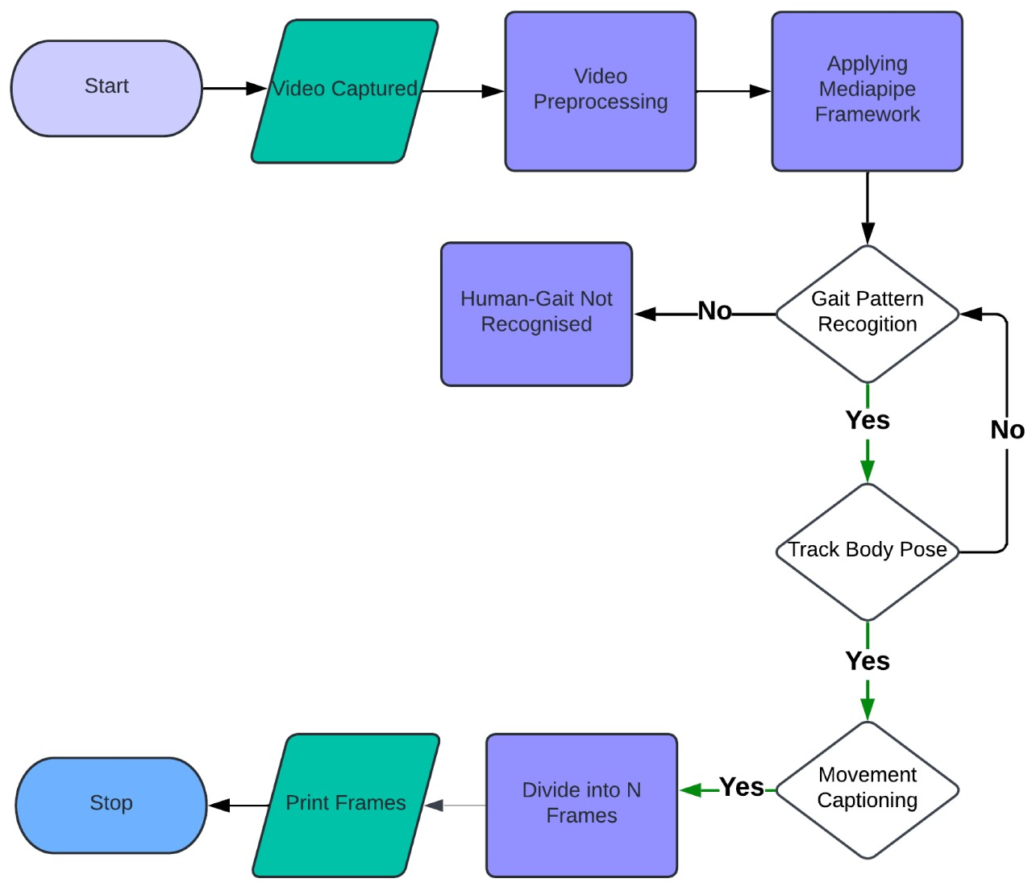

SCREENS

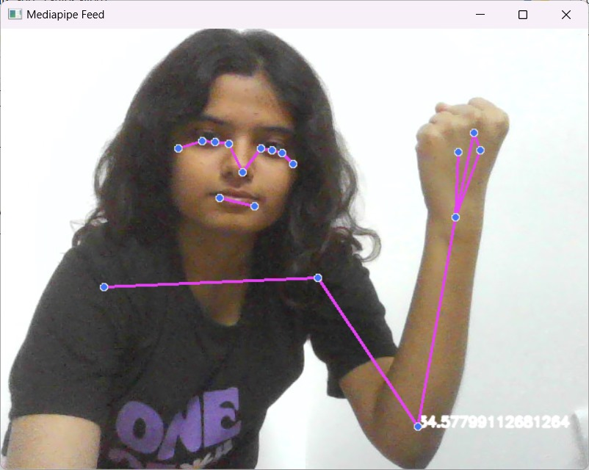
The image demonstrates real-time human pose estimation using MediaPipe Pose and OpenCV, detecting key body landmarks for motion analysis. It helps in fitness tracking, posture correction, and gesture recognition by capturing joint positions and movement patterns.
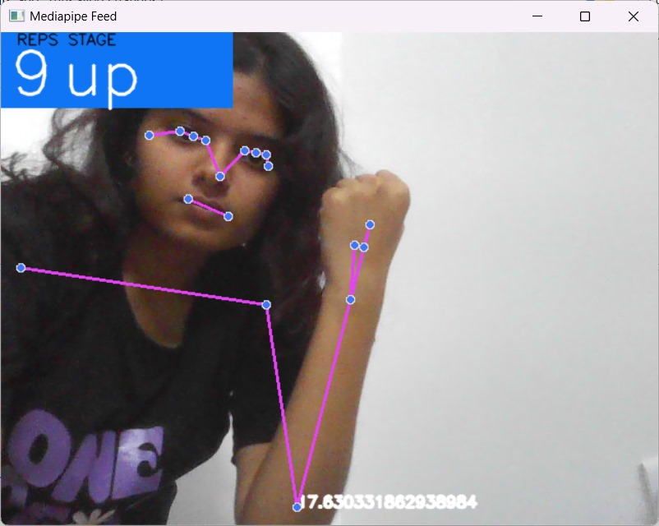

The image showcases real-time fitness tracking using MediaPipe Pose and OpenCV, detecting body
landmarks and counting exercise repetitions for posture analysis

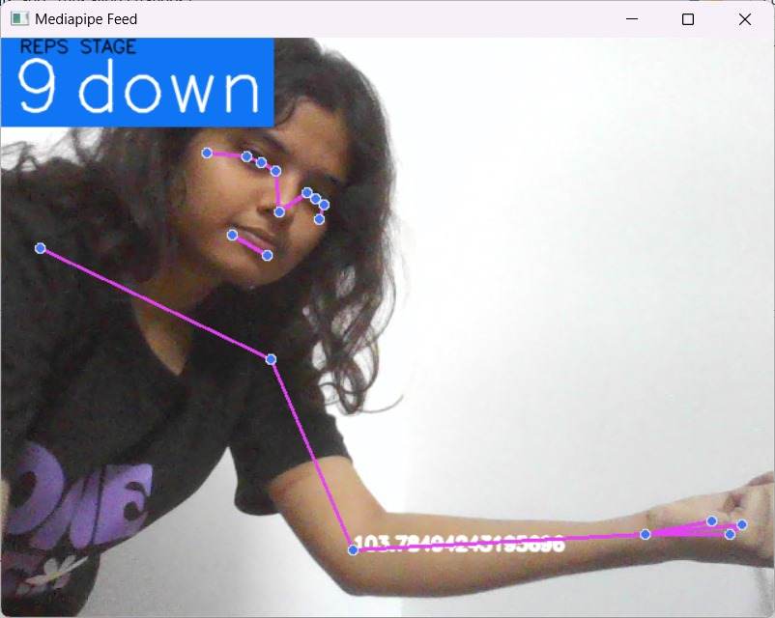

The image captures real-time exercise tracking using MediaPipe Pose and OpenCV, detecting body posture and counting repetitions with movement stage classification.

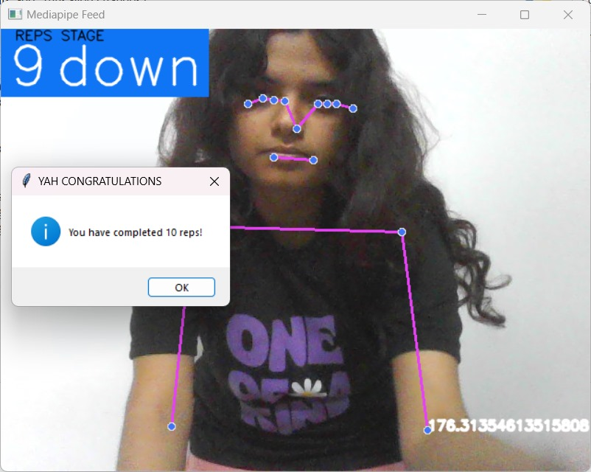
The image showcases real-time exercise tracking using MediaPipe Pose and OpenCV, detecting body movements, counting repetitions, and displaying a congratulatory message upon completing 10 reps.
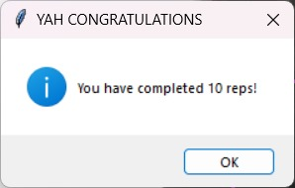

This image displays a popup message congratulating the user for completing 10 repetitions in a real-time exercise tracking system.

